**Soal Praktikum**

*1. Buat koneksi database Oracle dengan Java/Web berdasarkan project masing-masing.  
2. Buatlah CRUD pada salah satu tabel (boleh menggunakan GUI, Console atau Web).  
3. Terapkan salah satu konsep JOIN dan tampilkan pada project Anda.*

*4. Terapkan salah satu konsep VIEW dan tampilkan pada project Anda.)*

**Langkah Pertama***Buat koneksi database Oracle dengan Web*

**Query**

<?php

$username = "rizky_07041";

$password = "rizky";

$host = "localhost";

$port = "1521";

$db = "(DESCRIPTION=(ADDRESS = (PROTOCOL = TCP)(HOST = ".$host.")(PORT = ".$port."))(CONNECT_DATA=(SID=xe)))";

$conn = oci_connect($username, $password, $db);

if(!$conn){

echo "Gagal Koneksi Database";

}

?>

**Screenshot**

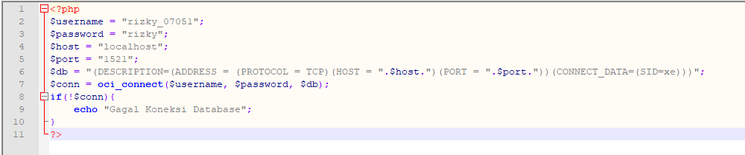

**Analisa**

*Koneksi PHP dengan Database Oracle*

**Langkah Kedua***CRUD di Tabel Pembeli (Read)*

**Query**

<?php

include 'connect.php';

?>

<h1>Tabel Pembeli</h1>

<?php

$q = "select * from pembeli";

$parsesql = oci_parse($conn, $q);

$tes = oci_execute($parsesql);

echo "

<table border=1>

<tr>

<td>ID NIK</td>

<td>Nama Pembeli</td>

<td>Jenis Kelamin</td>

<td>Alamat</td>

<td></td>

</tr>

";

while($rows=oci_fetch_object($parsesql)){

echo "

<tr>

<td>".$rows->ID_NIK."</td>

<td>".$rows->NAMA_PEMBELI."</td>

<td>".$rows->JENIS_KELAMIN."</td>

<td>".$rows->ALAMAT."</td>

<td><a href='edit_pembeli.php?id=".$rows->ID_NIK."'>Edit</a> || <a href='hapus_pembeli.php?id=".$rows->ID_NIK."'>Hapus</a></td>

</tr>

";

}

echo "

</table>

";

?>

<a href="tambah_pembeli.php">Tambah</a><br>

<a href="join_view.php">Join dan View</a>

**Screenshot**

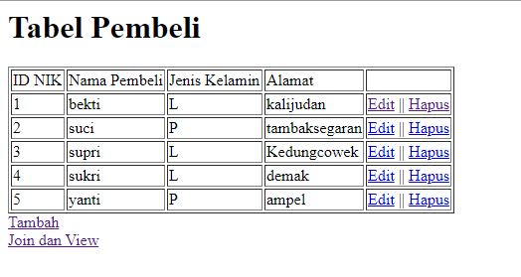

**Analisa :**

*Cetak tabel Pembeli di web browser via PHP*

**Langkah Ketiga***CRUD di Tabel Pembeli (Create)*

**Query**

<?php

include 'connect.php';

?>

<h1>Tambah Pembeli</h1>

<form method=POST>

<table>

<tr><td>ID NIK</td><td><input type=number name='id_nik'></td></tr>

<tr><td>Nama Pembeli</td><td><input type=text name='nama_pembeli'></td></tr>

<tr><td>Jenis Kelamin</td><td><input type=text name='jenis_kelamin'></td></tr>

<tr><td>Alamat</td><td><input type=text name='alamat'></td></tr>

<tr><td rowspan='2'><input type=submit name='submit'></td></tr>

</table>

</form>

<?php

if(isset($_POST['submit'])){

$id_nik = $_POST['id_nik'];

$nama_pembeli = $_POST['nama_pembeli'];

$jenis_kelamin = $_POST['jenis_kelamin'];

$alamat = $_POST['alamat'];

$q = "insert into pembeli values(".$id_nik.",'".$nama_pembeli."','".$jenis_kelamin."','".$alamat."')";

$parsesql = oci_parse($conn, $q);

oci_execute($parsesql);

}

?>

<a href="pembeli.php">Kembali</a>

**Screenshot**

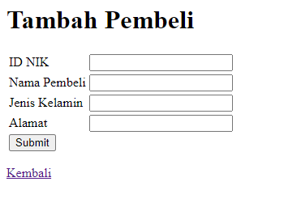

**Analisa :**

*Insert ke tabel Pembeli di web browser via PHP*

**Langkah Keempat***CRUD di Tabel Pembeli (Update)*

**Query**

<?php

include 'connect.php';

$q = "select * from pembeli where id_nik='".$_GET['id']."'";

$parsesql = oci_parse($conn, $q);

oci_execute($parsesql);

$rows=oci_fetch_object($parsesql);

?>

<h1>Edit Pembeli</h1>

<form method=POST>

<table>

<tr><td>ID NIK</td><td><input type=text name='id_nik' value='<?php echo $rows->ID_NIK; ?>'</td></tr>

<tr><td>Nama Pembeli</td><td><input type=text name='nama_pembeli' value='<?php echo $rows->NAMA_PEMBELI; ?>'></td></tr>

<tr><td>Jenis Kelamin</td><td><input type=text name='jenis_kelamin' value='<?php echo $rows->JENIS_KELAMIN; ?>'></td></tr>

<tr><td>Alamat</td><td><input type=text name='alamat' value='<?php echo $rows->ALAMAT; ?>'></td></tr>

<tr><td rowspan='2'><input type=submit name='submit'></td></tr></table></form>

<?php

if(isset($_POST['submit'])){

$id_nik = $_POST['id_nik'];

$nama_pembeli = $_POST['nama_pembeli'];

$jenis_kelamin = $_POST['jenis_kelamin'];

$alamat = $_POST['alamat'];

$q = "update pembeli set id_nik='".$id_nik."',nama_pembeli='".$nama_pembeli."', jenis_kelamin='".$jenis_kelamin."',alamat='".$alamat."' where id_nik = '".$_GET['id']."'";

$parsesql = oci_parse($conn, $q);

oci_execute($parsesql);

}

?>

<a href="pembeli.php">Kembali</a>

**Screenshot**

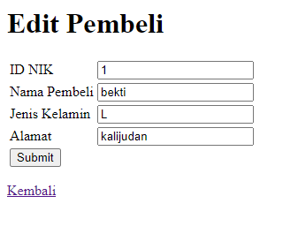

**Analisa :**

*Update ke tabel Pembeli di web browser via PHP*

**Langkah Kelima***CRUD di Tabel Heldpesk (Delete)*

**Query**

<?php

include 'connect.php';

?>

<h1></h1>

<form method=POST>

<h3>Hapus ID NIK <?php echo $_GET['id'];?> ?</h3>

<input type='submit' name='submit'> <a href='pembeli.php'>Kembali</a>

</form>

<?php

if(isset($_POST['submit'])){

$q = "delete from pembeli where id_nik ='".$_GET['id']."'";

$parsesql = oci_parse($conn, $q);

oci_execute($parsesql);

header('Location: pembeli.php');

}

?>

**Screenshot**

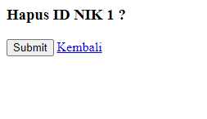

**Analisa :**

*Delete di tabel Pembeli di web browser via PHP*

**Langkah Keenam***Join dan View*

**Query**

<?php

include 'connect.php';

?>

<h1>Join</h1>

<?php

$q = "select a.id_pembayaran, b.nama_pembeli

from pembayaran a

left join pembeli b

on a.id_nik=b.id_nik

where a.harga_total >= (select min(harga_total) from pembayaran)

";

$parsesql = oci_parse($conn, $q);

oci_execute($parsesql);

echo "

<table border=1>

<tr>

<td>ID Pembayaran</td>

<td>Nama Pembeli</td>

</tr>

";

while($rows=oci_fetch_object($parsesql)){

echo "

<tr>

<td>".$rows->ID_PEMBAYARAN."</td>

<td>".$rows->NAMA_PEMBELI."</td>

</tr>

";

}

echo "

</table>

";

?>

<h1>VIEW</h1>

<?php

$q = "select * from list_pelanggan";

$parsesql = oci_parse($conn, $q);

oci_execute($parsesql);

echo "

<table border=1>

<tr>

<td>Nama Pembeli</td>

<td>Alamat</td>

</tr>

";

while($rows=oci_fetch_object($parsesql)){

echo "

<tr>

<td>".$rows->NAMA_PEMBELI."</td>

<td>".$rows->ALAMAT."</td>

</tr>

";

}

echo "

</table>

";

?>

<a href="pembeli.php">Kembali</a>

**Screenshot**

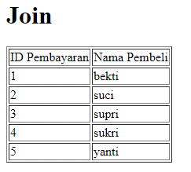 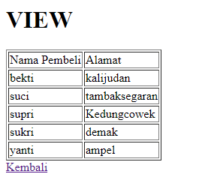

**Analisa :**

*View dan Join di web browser via PHP*